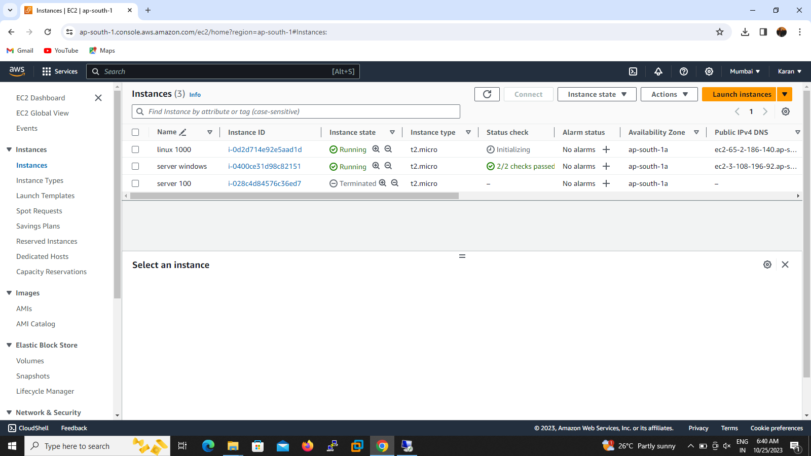

1.we are create linux instance and taken public ip Address from instance.then paste the putty console and select the autherentcation key file select from downloads and logon

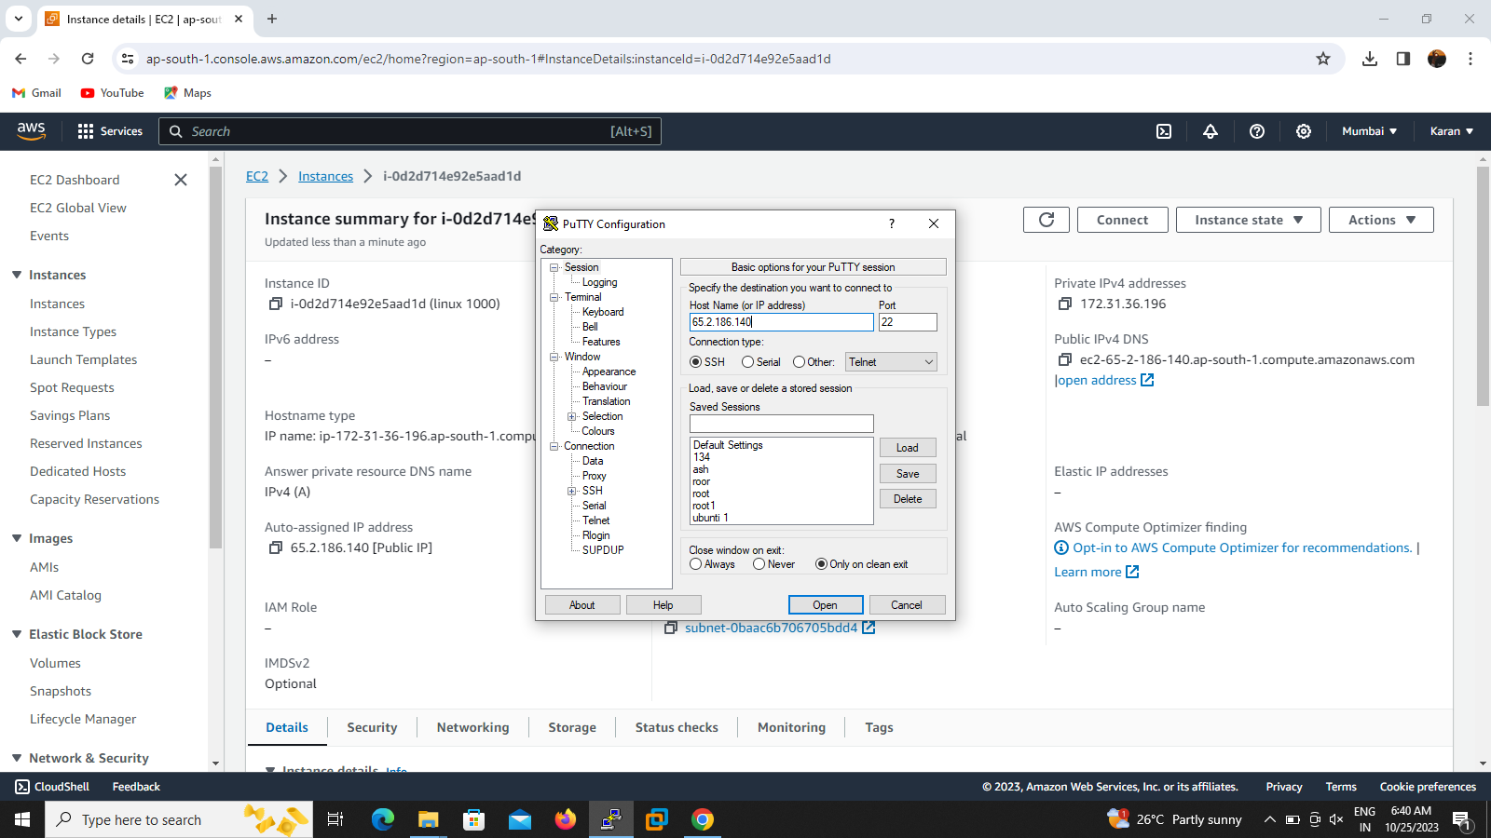

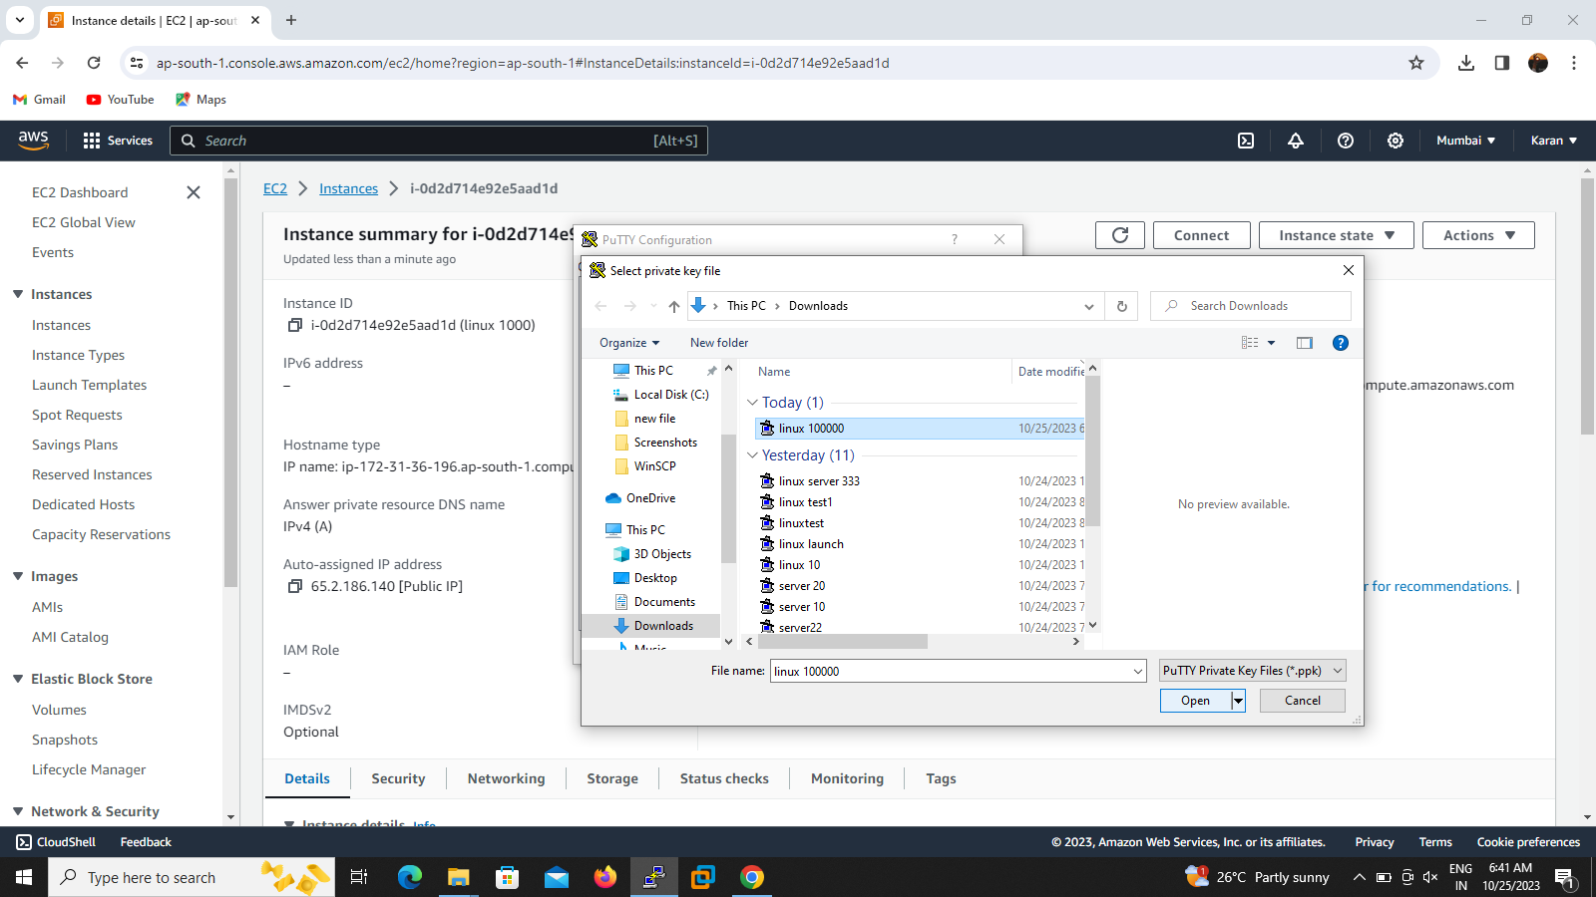

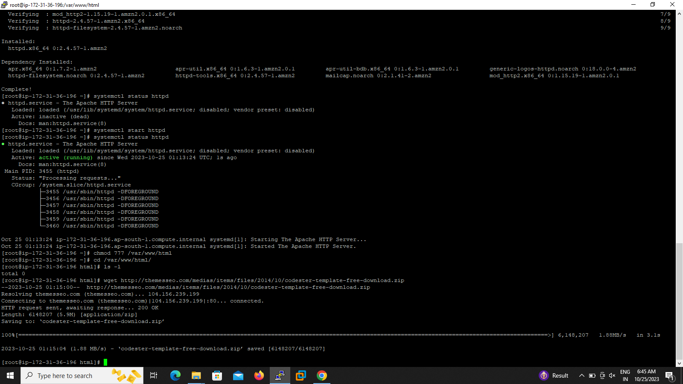

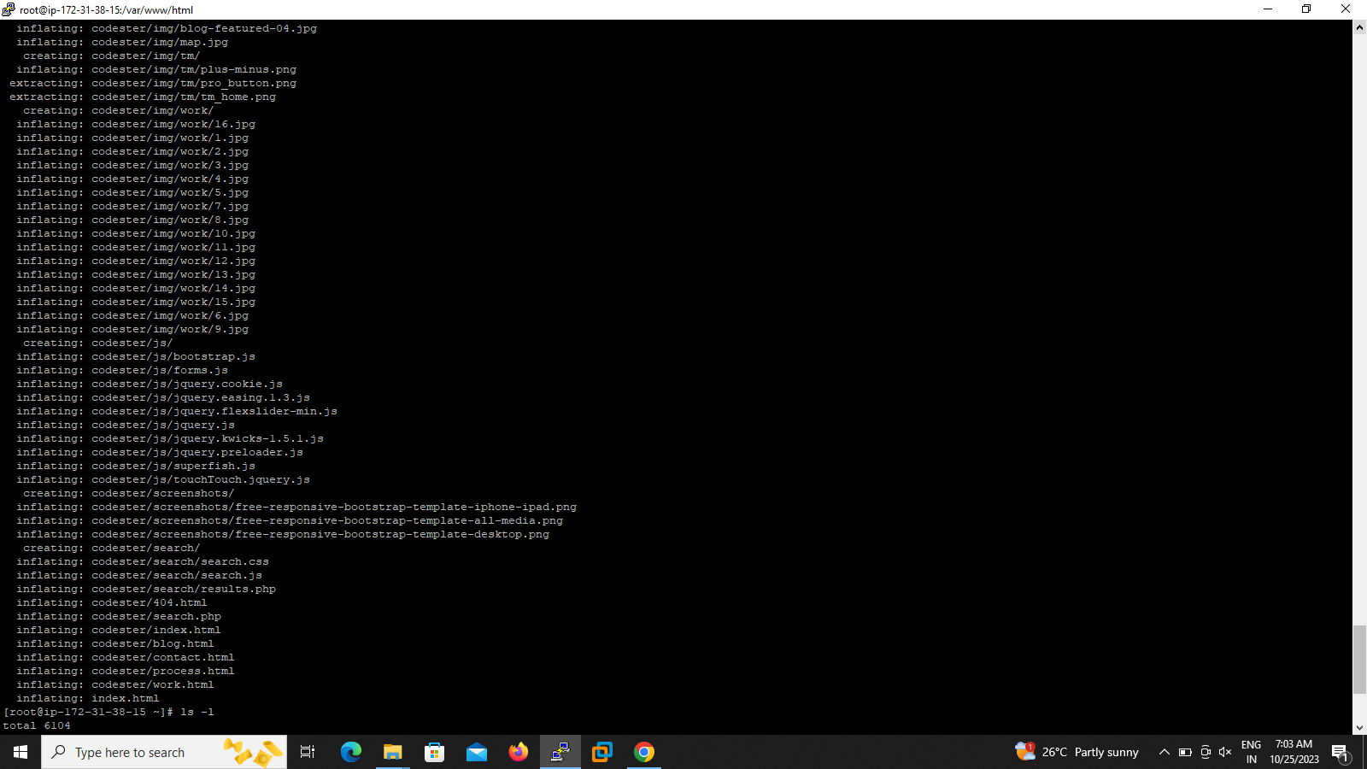

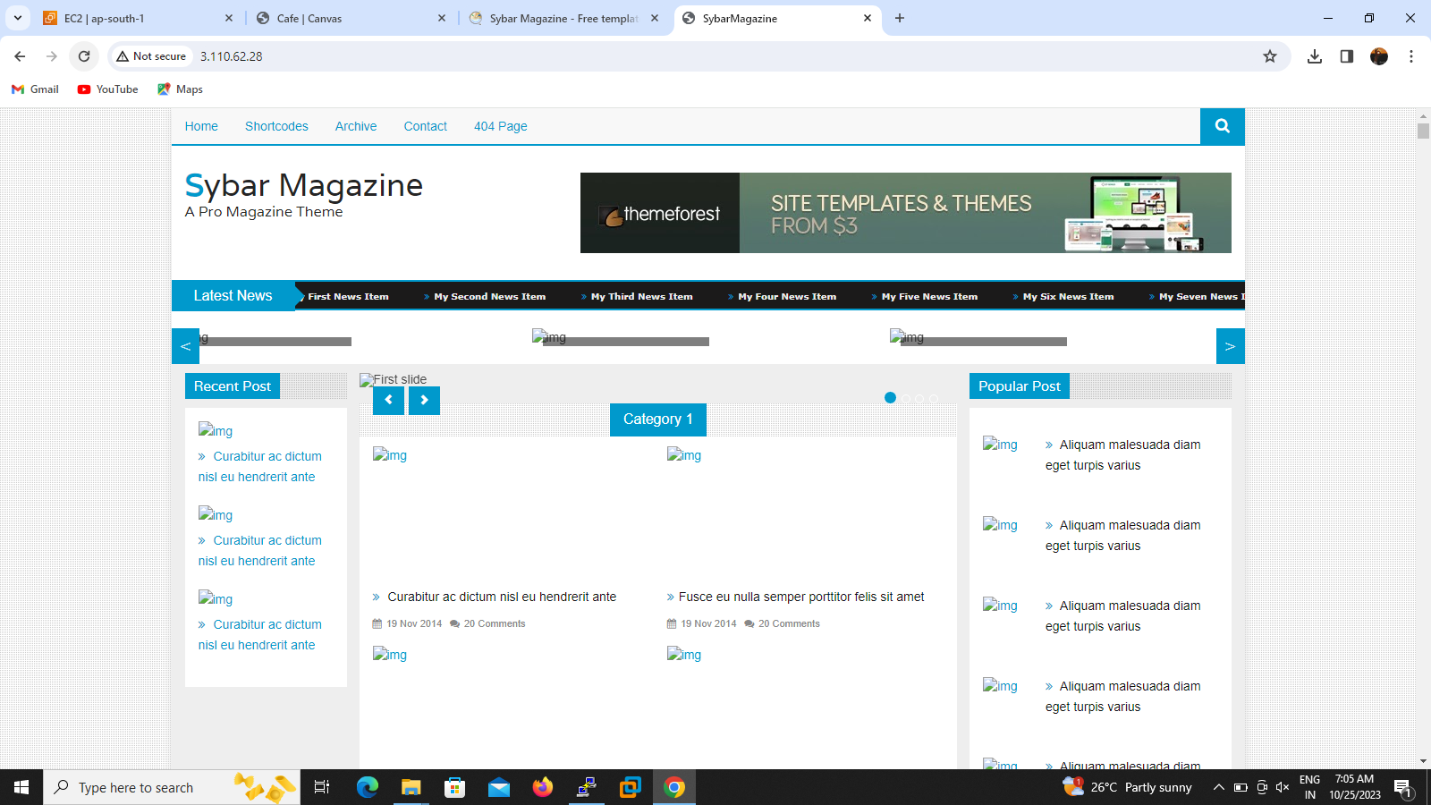

*2.Going to the putty console to login the user id – ec2-user*

*3.we will take full access permission so run the command sudo –i*

*4.instsll the httpd apache sever by the following command yum install httpd –y*

*5.start the service by use this command systemctl start httpd*

*6.To access the web template for anyone so you will run the command chmod 777 /var/www/html*

*7.go to html default directory cd /var/www/html*

*8.download web template from web browser and paste here wget (paste)*

*9.unzip the zipped file*

*10.paste the ip address to browser you can see the output*